

DRAFT
Technical Specification

Melbourne IT OFC
MIT OFC Visa Credit Card Interface Wrapper

Author: Tony Whelan
Creation Date: 7 March 2017
Last Updated: 29 March 2017
Version: 1.0
Table of Contents

1. MIT Requirements 3
2. Proposed Solution 3
3. Configuration and Development 4
3.1 Define Descriptive Flexfield Segments 4
3.2 Update Card Program DFF Interface Directory 4
3.3 Define Value Sets 5
3.4 Define Concurrent Program Executable 6
3.5 Define Concurrent Program 7
3.6 Update request Group 9
4. DBA Deployment Process 9
5. Functional Process 10
5.1 Load Visa files 10
5.2 Execute the Visa Wrapper 10
6. Outstanding Issues 10

MIT Requirements

The existing Visa Credit Card interface has a number of problems that need to be corrected to improve the current process:-
1. Each interface file and directory path has to be manually entered into the standard Visa VCF 4 Transaction Loader and Validation Program, leading to omissions and data entry errors.
2. Files can be processed more than once into the interface tables without error or warning.
3. Since there are approximately 20 interface files per month per Card Program, the process is time consuming and tedious.
4. These errors have a flow on effect to OFC Internet Expense processing.
5. Processed files remain in the current interface directory making it difficult to determine which files have been processed and which remain.
6. Files can be processed for the incorrect Operating Unit because there is no validation against the Card Program Operating Unit.

Proposed Solution

A Linux shell wrapper program will be developed to:-
- Process all files using standard Visa VCF Loader in the relevant interface directory in one pass
- Move all processed files from the current directory into an archive directory
- Validate and use the correct Operating Unit against the Card Program
- Validate and use the correct Interface directory path without having to enter it for every file.

Configuration and Development

Define Descriptive Flexfield Segments
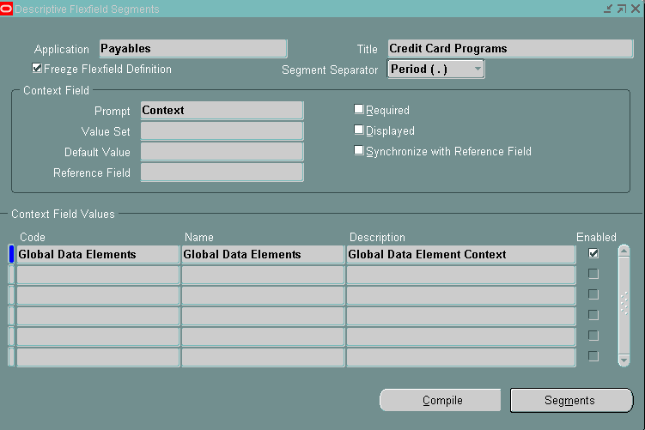

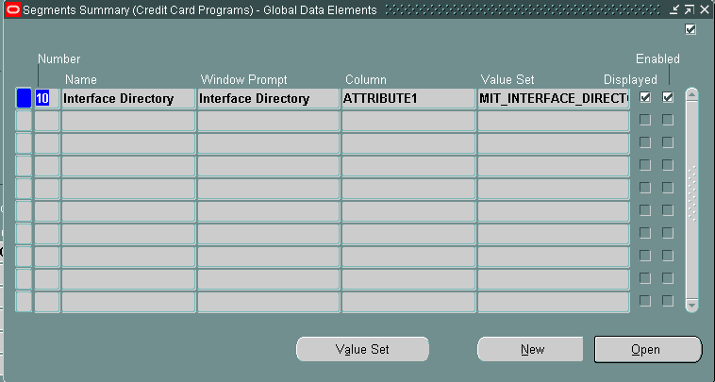

Update Card Program DFF Interface Directory
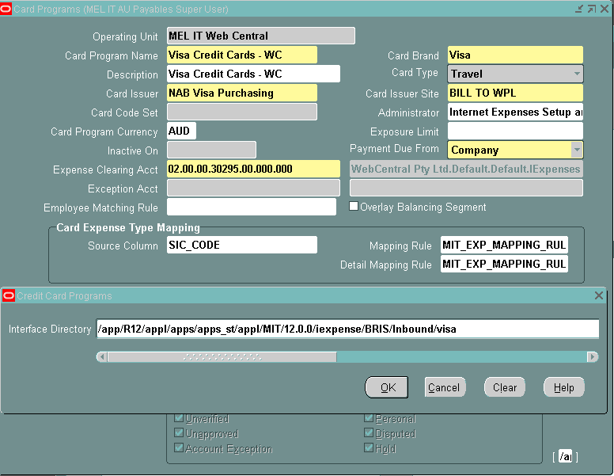

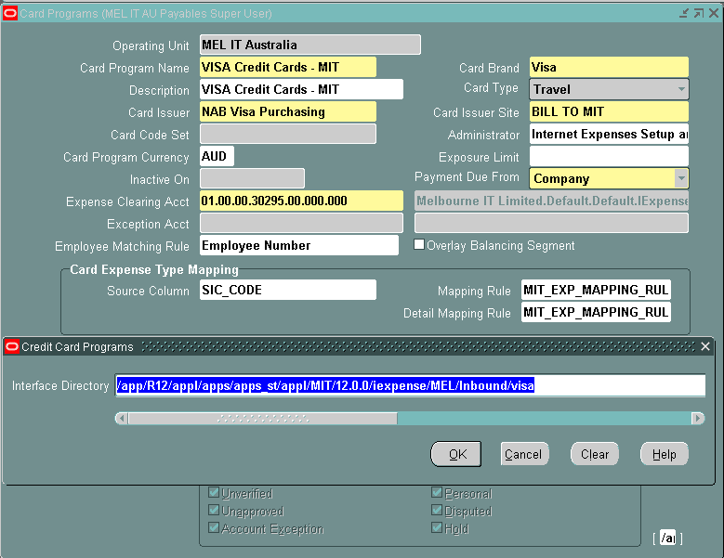

Define Value Sets
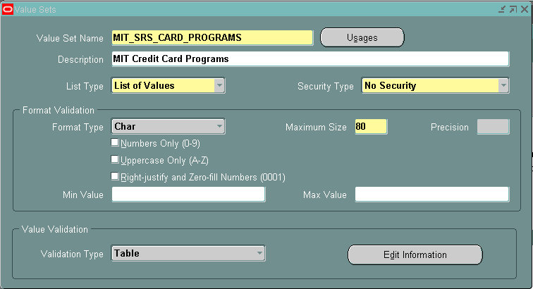

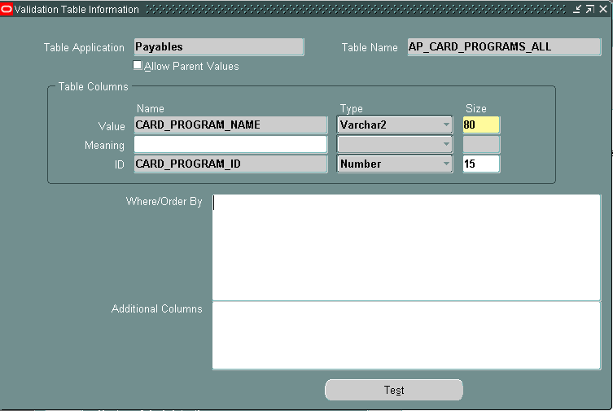

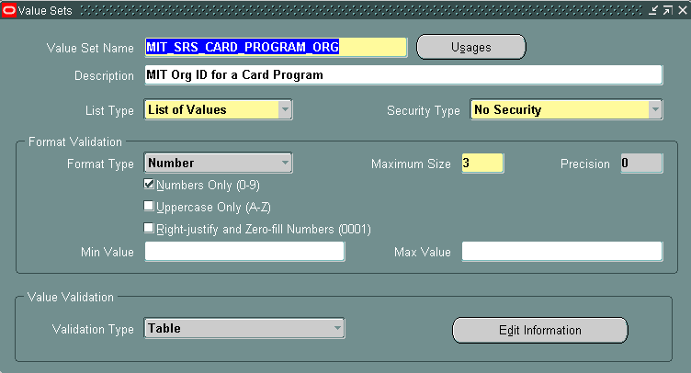

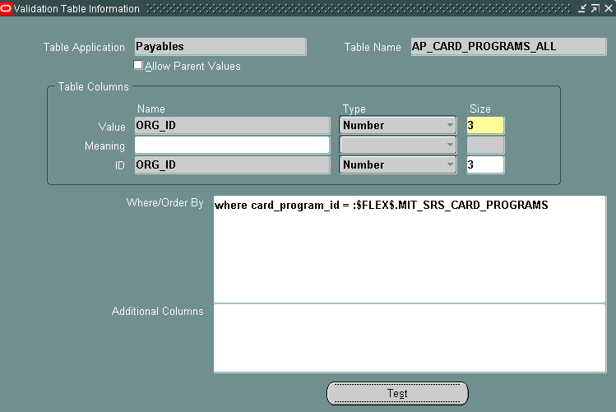

Define Concurrent Program Executable
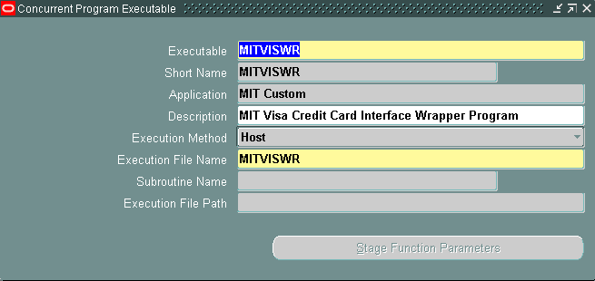

Define Concurrent Program
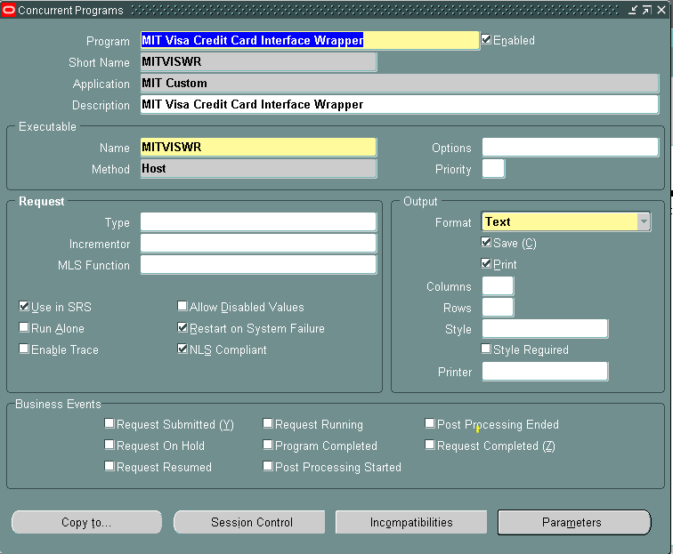

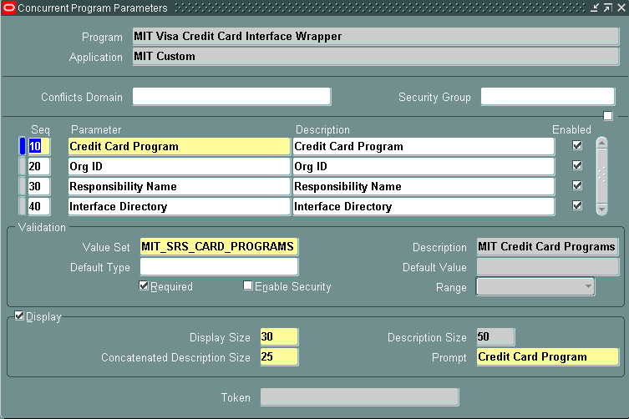

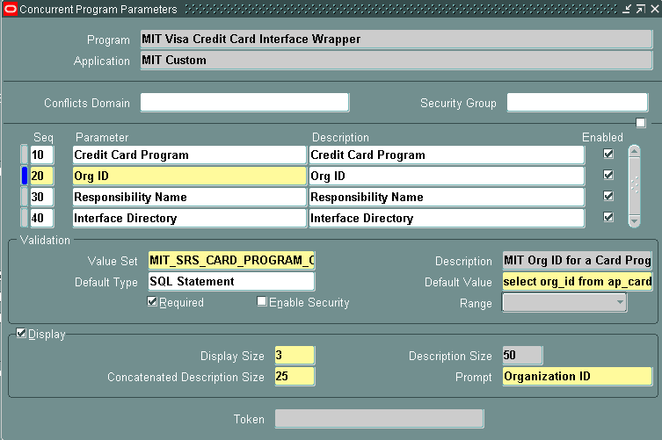

SQL Statement:
select org_id from ap_card_programs_all where card_program_id = :$FLEX$.MIT_SRS_CARD_PROGRAMS

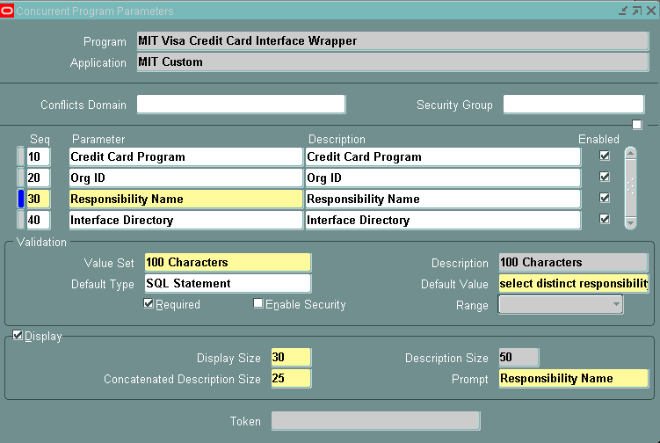

SQL Statement:
select distinct responsibility_name from fnd_responsibility_tl where responsibility_id = :$PROFILES$.resp_id

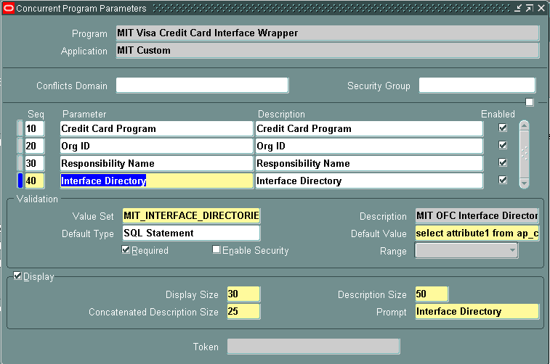

select attribute1 from ap_card_programs_all where card_program_id = :$FLEX$.MIT_SRS_CARD_PROGRAMS

Update request Group
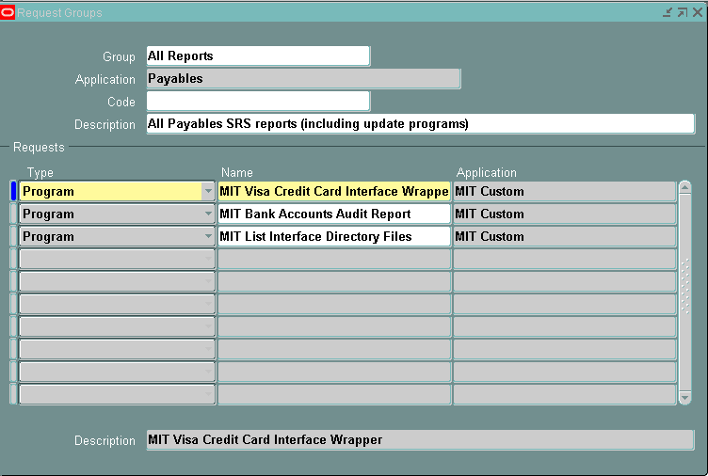

DBA Deployment Process
DBA tasks to deploy this program to OFC Production:-

- Create the following archive directories in OFC Production financials:-
  - /app/R12/appl/apps/apps_st/appl/MIT/12.0.0/iexpense/BRIS/Inbound/visa/archive
  - /app/R12/appl/apps/apps_st/appl/MIT/12.0.0/iexpense/MEL/Inbound/visa/archive

- Move all files with a date prior to Mar 2 2017 from the visa directories to archive directories
  - All the files dated prior to Mar 2 2017 in the /visa directories above have been processed through the Visa interface program and must be moved to the relevant /archive sub directory so they are not processed again.

- Copy linux script from Development findev2 to Production financials
  - Cp findev2:$MIT_TOP/bin/MITVISWR.prog financials: :$MIT_TOP/bin/MITVISWR.prog

- Convert prog file from dos to unix
  - cd $MIT_TOP/bin
  - dos2unix MITVISWR.prog

- Set permissions for the prog file to 755
  - Chmod 755 MITVISWR.prog

- Define a symbolic link to MITVISWR.prog
  - ln –s $FND_TOP/bin/fendcpesr $MIT_TOP/bin/MITVISWR

Functional Process

Load Visa files
Request the DBA to load the Visa files into the relevant interface directory:-
Melbourne IT: /app/R12/appl/apps/apps_st/appl/MIT/12.0.0/iexpense/MEL/Inbound/visa
Web Central: /app/R12/appl/apps/apps_st/appl/MIT/12.0.0/iexpense/BRIS/Inbound/visa

Execute the Visa Wrapper
Execute the MIT Visa Credit Card Interface Wrapper for the relevant Card Program
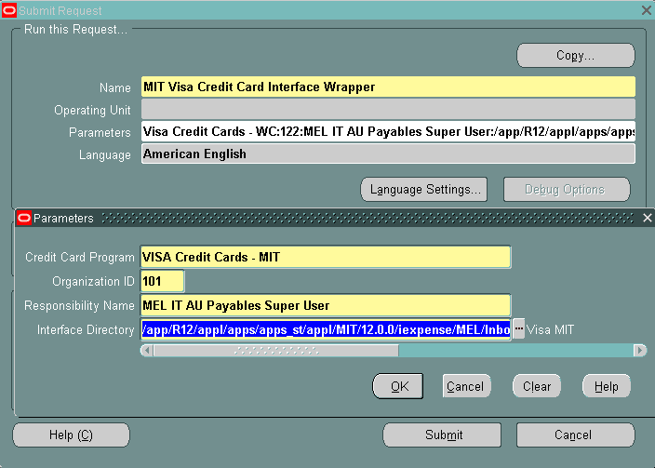

It will execute the standard Visa VCF 4 Transaction Loader once for every file in the visa interface directory, and move the processed files into the archive directory.
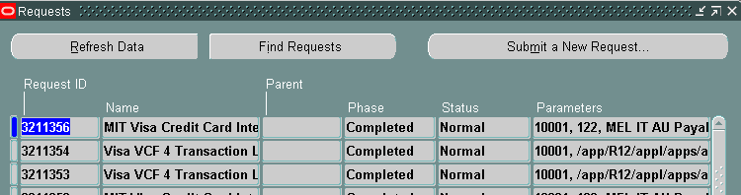

The Wrapper will complete with an Error status if there are no Visa interface files to process.

Outstanding Issues

